Implementation of some canopy budget models in R

Table of content

General information 2

Getting started 2

Abbreviations 2

Remarks 2

Files 2

CBM_Demo.R 2

DemoData.csv 3

Documentation.pdf 3

CalculateCBMs.R 3

Parameters 3

Output 4

References 6

Appendix 6

Correction function for deposition estimates based on weak acids calculated according to the charge balance method 6

Andreas Schmitz, Thünen Institute of Forest Ecosystems

Bernd Ahrends, Northwest German Forest Research Station

Henning Andreae, Sachsenforst - Competence Centre Wood and Forestry

Please report and bugs and suggestions to [andreas.schmitz@thuenen.de](mailto:andreas.schmitz@thuenen.de)

# General information

This script implements the canopy budget models according to Ulrich (1991), Draaijers and Erisman (1995) and de Vries et al. (2001). It calculates annual total deposition to forest, canopy leaching and canopy uptake for a range of substances (see below) based on annual deposition rates in the open field and under canopy.

# Getting started

* Download and install [R](https://www.r-project.org/) and potentially a profession graphic user interface like [RStudio](https://www.rstudio.com/).
* [Download all files](https://tc.thuenen.de/index.php/s/CAmXkXSYwYI7nyu) (password: “CBMScript”) and store them in a folder (working directory).
* Open the file CBM_Demo.R.
* Set the variable “WorkDir” to your working directory.
* Execute the script.

# Abbreviations

Abbreviations used in this documentation:

* CBM: Canopy budget model
* OF: Open field deposition
* UC: Deposition under canopy (throughfall + stemflow)
* U91: According to Ulrich (1991)
* D95: According to Draaijers and Erisman (1995)
* V01: According to de Vries et al. (2001)

# Remarks

* All negative flux rates and factors occurring during calculations are set to zero before further processing (e.g. negative dry deposition factors, negative rates of canopy uptake, etc.).

# Files

## CBM_Demo.R

This script reads the input file, calls the CalculateCBMs() function to calculate the canopy budget models and saves the output.

## DemoData.csv

Example of input data.

|  |  |
| --- | --- |
| Column | Description |
| code_country, code_plot, survey_year | CBMs are calculated per plot and year. These columns are used to identify plot-years. Country and plot codes can be chosen arbitrarily. |
| SamplingType | “UC” if the row contains deposition rates under canopy (throughfall + stemflow) or “OF” if the row contains open field deposition rates. |
| h, n_nh4, n_no3, mg, ca, k, na, cl, s_so4 | Annual gap-filled deposition rates of the corresponding substances in $kg {ha}^{-1}a^{-1}$. n_nh4 and n_no3 refer to the mass of nitrogen and not to the mass of the nitrate and ammonium. s_so4 refers to the mass of sulfur and not to the mass of sulfate. |
| WeakAcids_MA | Annual gap-filled deposition rates of weak acids in $keq {ha}^{-1}a^{-1}$ calculated according to measured alkalinity method. The concentration of weak acids in a deposition sample can be calculated as [WA] = Alkalinity + [$H^{+}$] – [${OH}^{-}$] (Marchetto et al., 2017). See section Parameters for other options if annual deposition rates according to the measured alkalinity method are not available. |
| n_org | Annual gap-filled deposition rates of organic N in $kg {ha}^{-1}a^{-1}$. Not required for most CBM calculations / only required for specific output quantities. Set to zero if you are not interested in these output quantities. |

## Documentation.pdf

This documentation.

## CalculateCBMs.R

This script implements some canopy budget models as a R-function.

### Parameters

* AnnualDepositionRates: A data frame representing the annual deposition rates UC and OF per plot and year. See section DemoData.csv for more information.
* TracerSubstance: Tracer substance to estimate particulate dry deposition for other substances. One of "Na", "S_SO4" or "Cl". Sodium is the most common tracer substance.
* WA_DD_rel_WA_OF : Only relevant for CBMs D95 and V01. Dry deposition of weak acids as a proportion of open field deposition of weak acids. D95 and V01 assume 1:1 ratio (WA_DD_rel_WA_OF = 1).
* Uptake_efficiency_H_vs_NH4: Only relevant for CBMs D95 and V01. Canopy uptake efficiency of $H^{+}$ as a proportion of the canopy uptake efficiency of ${NH}_{4}^{+}$. D95 and V01 assume a value of 6.
* Uptake_efficiency_NH4_vs_NO3: Only relevant for CBM V01. Canopy uptake efficiency of ${NH}_{4}^{+}$ as a proportion of the canopy uptake efficiency of ${NO}_{3}^{-}$. V01 assumes a value of 6.
* ApplyWetOnlyCorrection: Define whether to apply wet-only correction to bulk deposition rates (“yes” or “no”). The implemented correction factors have been established based on parallel measurements of wet-only and bulk deposition in Germany (Gauger et al., 2008). They range between 0.62 for $K^{+}$ and 0.95 for ${NH}_{4}^{+}$.
* WeakAcidGapFilling: Only relevant for CBMs D95 and V01. Defines how missing values in the column “WeakAcids_MA” in the “AnnualDepositionRates “ input dataframe are treated. Set to “none” to propagate missing values through all calculations (resulting for example in missing values for total nitrogen deposition rates). Set to “CB” if missing values should be replaced by calculations of the weak acid deposition rates according to the charge balance method (see de Vries et al. (2001) p. 147 ff. or Appendix for details). Note that the charge balance method leads to biased estimates and is considered less correct compared the measured alkalinity method (Marchetto et al., 2017). Set to “CB_WithCorrection” if missing values should be treated identical to option “CB”, but in addition an empirical correction function is applied in order to yield unbiased estimates compared to the measured alkalinity method (see Appendix for details). Note that the empirical correction function has been established based on data from Germany.

### Output

The CalculateCBMs() function returns a list containing the two data frames “CBM_Results_kg_ha_a” and “CBM_Results_keq_ha_a” which contain essentially the same information. In “CBM_Results_kg_ha_a”, most of the columns refer to annual flux rates in $kg {ha}^{-1}a^{-1}$. Flux rate with no meaningful representation in $kg {ha}^{-1}a^{-1}$ are reported in $keq {ha}^{-1}a^{-1}$, identified by the string “_keq” in the corresponding column names. “CBM_Results_keq_ha_a” reports all flux rates in $keq {ha}^{-1}a^{-1}$. The following documentation refers to the “CBM_Results_kg_ha_a” output.

|  |  |
| --- | --- |
| Column | Description |
| code_country, code_plot, survey_year, H_UC, N_NH4_UC, , N_NO3_UC, Mg_UC, Ca_UC, K_UC, Na_UC, Cl_UC, S_SO4_UC, N_Org_UC, H_OF, N_NH4_OF, N_NO3_OF, Mg_OF, Ca_OF, K_OF, Na_OF, Cl_OF, S_SO4_OF, N_Org_OF | A copy of the input data. If the parameter *ApplyWetOnlyCorrection* is set to TRUE, then the reported open field input data is corrected for dry deposition to bulk samplers. |
| DDF | Dry deposition factor according to U91 (identically used in all other CBM variants) |
| Na_DD_p, K_DD_p, Mg_DD_p, Ca_DD_p, N_NH4_DD_p, S_SO4_DD_p, Cl_DD_p, N_NO3_DD_p, H_DD_p | Dry particulate deposition according to U91 |
| Na_TD, K_TD, Mg_TD, Ca_TD | Total deposition according to U91 |
| N_NH3_DD_g, N_NO3_DD_g, Cl_DD_g, S_SO4_DD_g, H_DD_g | Gaseous deposition according to U91 |
| N_NH4_TD_U91, N_NO3_TD_U91, N_TD_U91 | Total deposition of nitrogen species according to U91 |
| WA_UC_MA_keq, WA_OF_MA_keq | A copy of the input data |
| CatIon_UC_keq, Anion_UC_keq, CatIon_OF_keq, Anion_OF_keq | Cation and anion sums |
| WA_UC_CB_keq, WA_OF_CB_keq | Weak acids according to the charge balance method |
| WA_UC_keq, WA_OF_keq | Identical to columns WA_UC_MA_keq and WA_OF_MA_keq but with gaps (NA) filled by columns WA_UC_CB_keq and WA_OF_CB_keq if parameter *WeakAcidGapFilling* is set to “CB” or “CB_WithCorrection” |
| WA_DD_keq, WA_CL_keq | Dry deposition and canopy leaching of weak acids |
| K_CL, Ca_CL, Mg_CL | Canopy leaching of base cations |
| EF_D95 | Excretion factor as defined in D95 |
| BC_CL_D95_keq | Excretion factor corrected leaching of base cations according to D95 |
| H_CU_D95, N_NH4_CU_D95 | Canopy uptake of protons and ammonium according to D95 |
| N_NH4_TD_D95, H_TD_D95, N_NO3_TD_D95, N_TD_D95, S_SO4_TD_D95, S_SO4_TD_V01 | Total deposition of corresponding substances according to D95 |
| BC_CL_V01_keq | Canopy leaching of base cations according to V01 |
| N_NH4_H_CU_V01_keq, H_CU_V01, N_NH4_CU_V01, N_CU_V01 | Canopy uptake of protons and ammonium, the sum of both and the canopy uptake of nitrate according to V01 |
| N_NH4_TD_V01, N_NO3_TD_V01, N_TD_V01, H_TD_V01 | Total deposition of corresponding substances according to V01 |
| N_TD_LowerBoundary, N_TD_UpperBoundary | Reporting of total deposition of nitrogen according to a consensus among German ICP Forests partners in 2018: The lower boundary is the deposition of inorganic N in the open field or under canopy (the higher of the two values) plus the open field deposition of organic N. The upper boundary is the total N deposition according to U91 or V01 (the higher of the two values) plus the open field deposition of organic N. |
| H_TD_U83ClSO2_keq, H_TD_U83SO2_keq, Ac_TD_U83_keq, Ac_TD_U91_keq, AC_TD_D95_keq, H_CU_U83_keq, H_CU_U83Cl_keq, H_CU_U91_keq | Various variants for calculating the total deposition (TD) and canopy uptake (CU) of protons / acidity. See code section “#Acid deposition” for details on calculation. |

# References

de Vries, W., Reinds, G.J., van der Salm, C., Draaijers, G.P.J., Bleeker, A., Erisman, J.W., Auée, J., Gundersen, P., Kristensen, H.L., van Dobben, H., de Zwart, D., Derome, J., Voogd, J.H.C., Vel, E.M., 2001. Intensive Monitoring of Forest Ecosystems in Europe - Technical Report 2001.

Draaijers, G.P.J., Erisman, J.W., 1995. A canopy budget model to assess atmospheric deposition from throughfall measurements. Water Air Soil Pollut 85, 2253–2258. https://doi.org/10.1007/BF01186169

Gauger, T., Haenel, H.-D., Rösemann, C., Dämmgen, U., Bleeker, A., Erisman, J.W., Vermeulen, A.T., Schaap, M., Timmermanns, R.M.A., Builtjes, P.J.H., Duyzer, J.H., 2008. National Implementation of the UNECE Convention on Long-range Transboundary Air Pollution (Effects) - Part 1: Deposition Loads: Methods, modelling and mapping results, trends. Bundesforschungsanstalt für Landwirtschaft Institut für Agrarökologie.

Marchetto, A., Koenig, N., Mosello, R., 2017. Organic acids in deposition. Presented at the ICP Forests Conbine expert panel meeting, Zagreb.

Ulrich, B., 1991. Rechenweg zur Schätzung der Flüsse in Waldökosystemen - Identifizierung der sie bedingenden Prozesse, in: Berichte Des Forschungszentrums Waldökosysteme, Reihe B, Band 24.

# Appendix

## Correction function for deposition estimates based on weak acids calculated according to the charge balance method

The correct calculation of the concentration of weak acids is the “measured alkalinity approach” (Marchetto et al., 2017):

$$Alk=\left[HCO_{3}^{-}\right]+ {\left[{RCOO}^{-}\right]}^{weak}+[{OH}^{-}]-[H^{+}]$$

Which yields:

$$\left[WA\right]=Alk-\left[{OH}^{-}\right]+[H^{+}]$$

An alternative approach to calculate the concentrations of weak acids is the “charge balance approach”:

$$\left[WA\right]=\left[{Ca}^{2+}\right]+\left[{Mg}^{2+}\right]+[{Na}^{+}]+{[K}^{+}]+[H^{+}]+[{NH}_{4}^{+}]-[{SO}_{4}^{2-}]-[{NO}_{3}^{-}]-[{Cl}^{-}]$$

However, in this approach the concentration of strong(er) organic acids affects the weak acid concentration (Marchetto et al., 2017). For the estimation of the total nitrogen deposition, the charge balance approach leads to an underestimation of 2 $kg N {ha}^{-1}a^{-1}$ on average per plot-year based on the V01 model and data from German Level II sites between 2000 and 2015. Unfortunately, limitations in the availability of alkalinity measurements constrain the applicability of the measured alkalinity (MA) approach, especially for older data. Thus, an empirical transfer function from calculations based on the CB approach to the MA approach has been established.

While a comparison between annual deposition rate of weak acids under canopy according to the MA approach and the CB approach showed no clear relation (fig. 1),

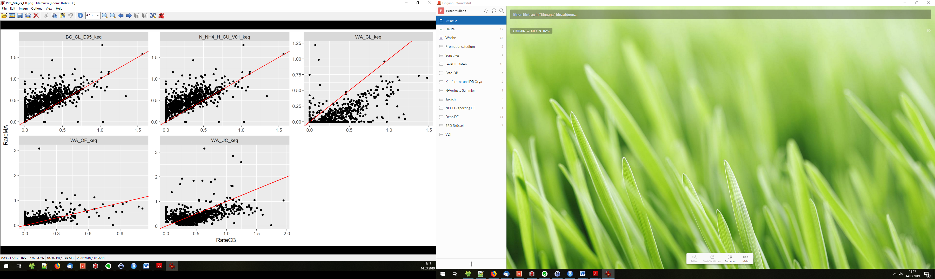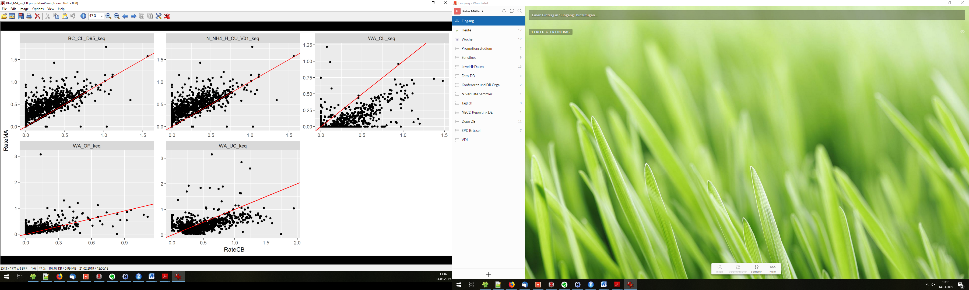

Figure 1: Comparison between annual deposition rate of weak acids in $keq {ha}^{-1}a^{-1}$ under canopy according to the MA approach and the CB approach based on data from German Level II sites between 2000 and 2015. The red line indicates a 1:1 relation.

further explorations revealed a better relation for the annual weak-acid corrected leaching of base cations (fig. 2) (referred to as ${CL}_{BC}$ in Draaijers and Erisman (1995) and as the sum of ${NH}_{4,ce}$ and $H_{ce}$ in de Vries et al. (2001)).

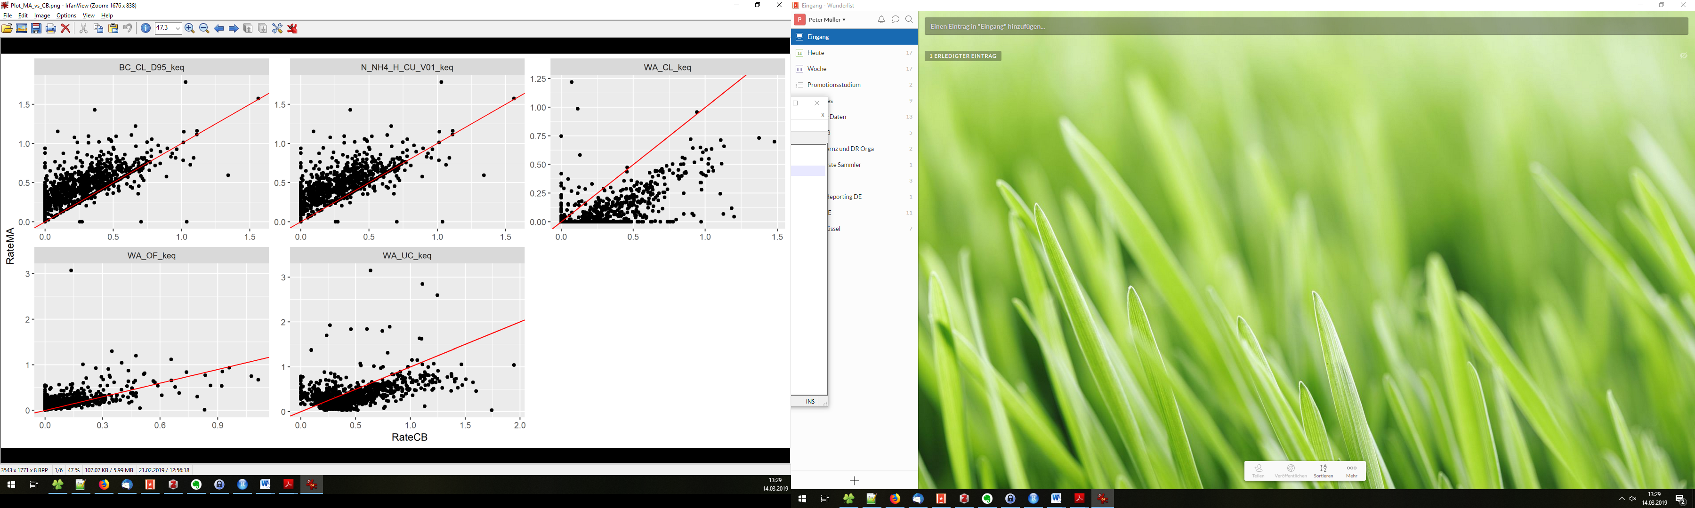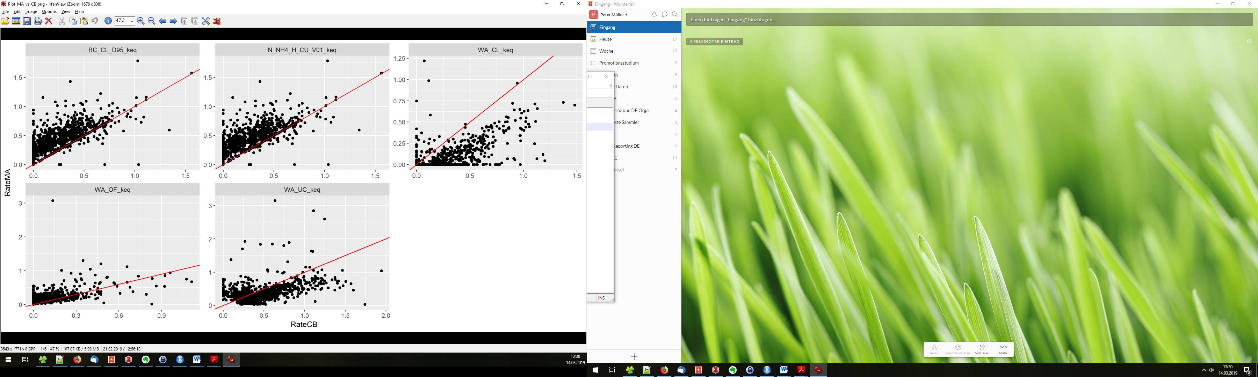

Figure 2: Comparison between the annual weak-acid corrected leaching of base cations in $keq {ha}^{-1}a^{-1}$ according to the MA approach and the CB approach based on data from German Level II sites between 2000 and 2015. The red line indicates a 1:1 relation.

Based on data from German Level II sites between 2000 and 2015, the following empirical transfer function from calculation based on the CB approach to calculation based on the MA approach was established:

$BC_CL_D95_corrected=$ 0.284 + $0.638*$ BC_CL_D95

The resulting estimation of the total deposition of nitrogen according to the V01 model based on the “CB approach with correction” compared to the MA approach has a bias of -0.14 $kg N {ha}^{-1}a^{-1}$ (compared to -2 $kg N {ha}^{-1}a^{-1}$ in the uncorrected case) and a RMSE of 1.8 $kg N {ha}^{-1}a^{-1}$ (fig. 3). Separate transfer functions for broadleaf, conifer and mixed forest sites have been tested but did not improve the RMSE in a relevant magnitude (not shown).

Note that this approach is applied at a relatively early calculation step during the CBM procedure. This means that all columns in the output dataframe reflect the correction, except for the columns "WA_OF","WA_UC","WA_DD","WA_CL" and "EF_D95".

|  |  |
| --- | --- |
|  |  |

Figure 3: Comparison of the annual total deposition of nitrogen according to the V01 model in $kg N {ha}^{-1}a^{-1}$ between the MA approach and the CB approach (left) and the MA approach and the CB approach with correction (right). Points represent data from German Level II sites between 2000 and 2015. The red line indicates a 1:1 relation.

Recommendation: If annual deposition rates of weak acids according to the MA approach are not available, set parameter “WeakAcidGapFilling” to “CB_WithCorrection” in order to let the script calculate weak acids based on the CB approach and apply the empirical correction function.